14) Create a Snapshot of a VM and Test it by loading the Previous Version/Cloned

VM

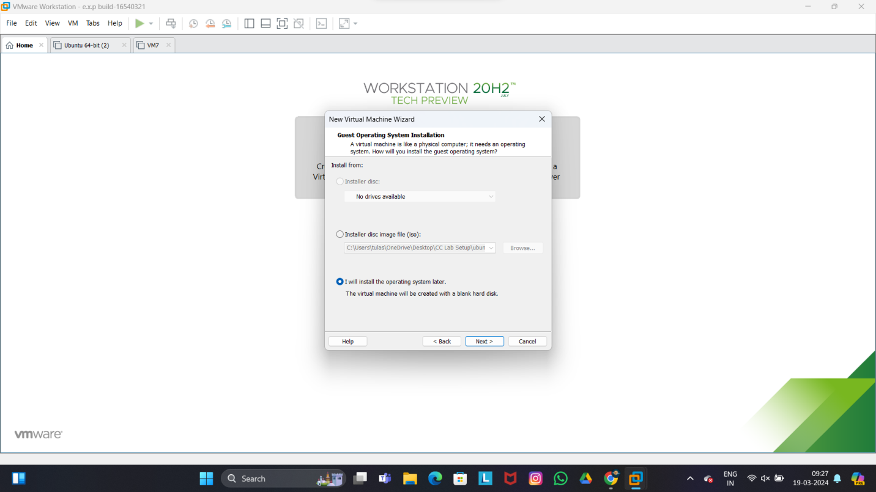

Step 2

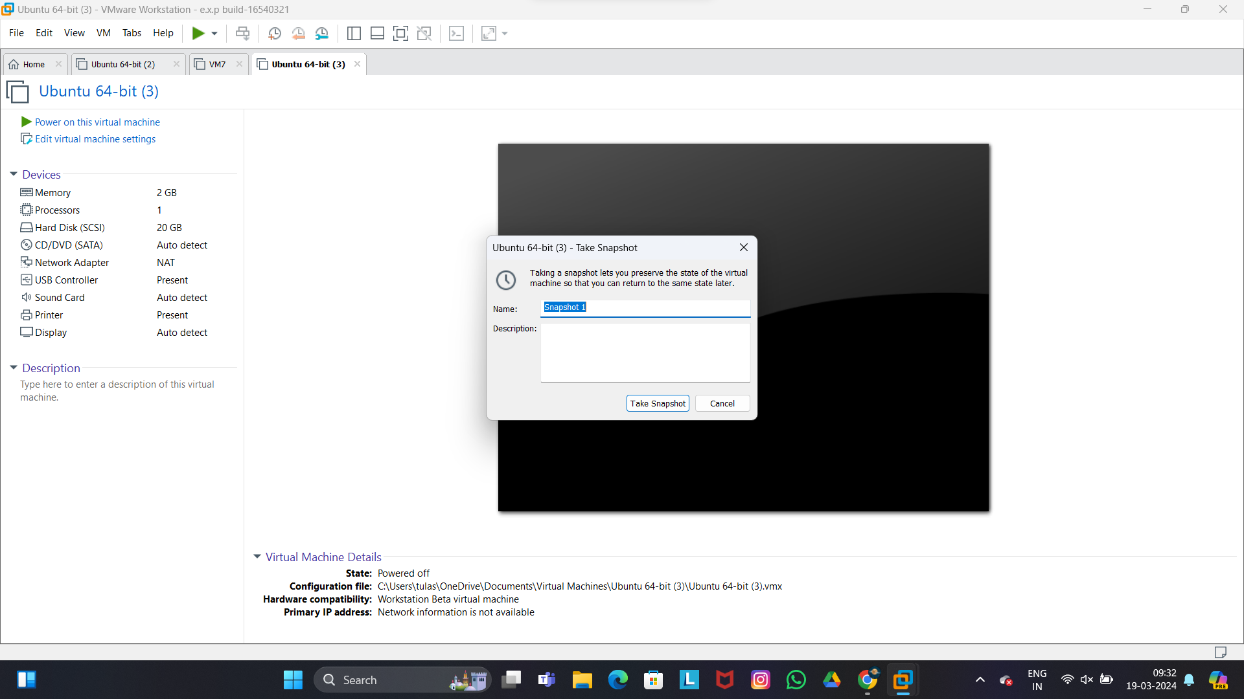

Step 3



Step 4

